Software Development Unit 1, 1.1

## Anna Legaspi

Macros enable repeating the same task over and over again which helps in being more productive and time efficient. For example, I’ve formatted a section of text to look a certain way and I want to apply it to specific parts of my document. Instead of highlighting and making multiple changes on a single section (i.e., font type, font size, bold, italic, etc), I can just apply a Macro on the relevant sections instead.

## Steps on creating, recording, editing and applying a Macro.

Go to the Developer tab in the Ribbon and select Macros.

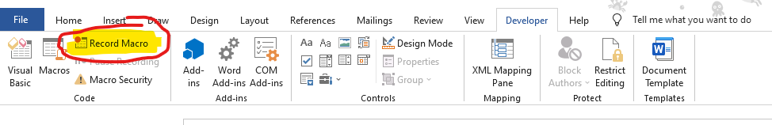

Input a name for your Macro under***Macro name***.

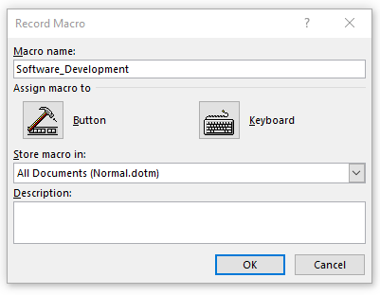



Press ***keyboard*** and you’ll be taken to ***Customize Keyboard.***

Under Press new shortcut key, input a shortcut key to allocate to your Macro. Try and avoid shortcuts that already exist. In this scenario, I’m using ***Alt+T*** as my shortcut.

Select ***Assign*** and ***Close***

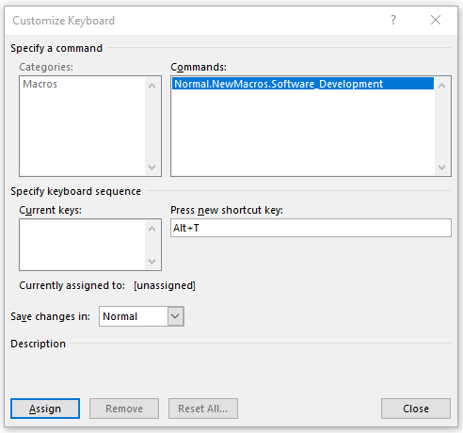



For this demonstration, I’ve copy pasted a paragraph 5 times and will apply the changes on each paragraph.

The original text is Font type ***Arial*** and Font size ***11***.

I changed the first paragraph to the following:

* Green font
* Italic
* Bold
* Yellow highlight

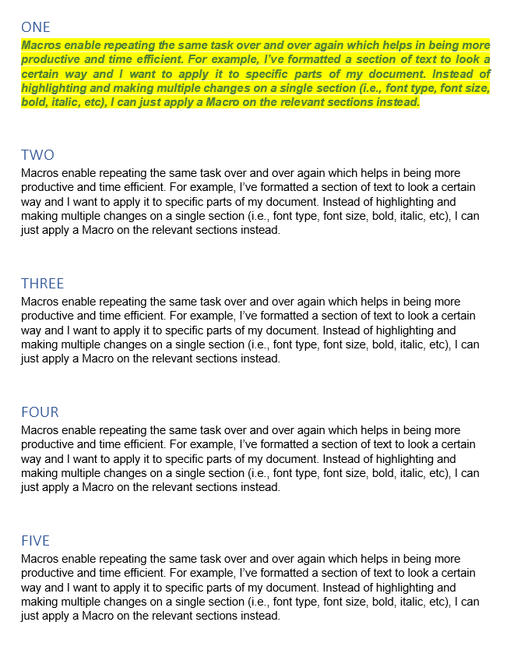

Once I’ve completed all the editing, I select ***Stop Recording*** under the ***Developer*** tab Ribbon.

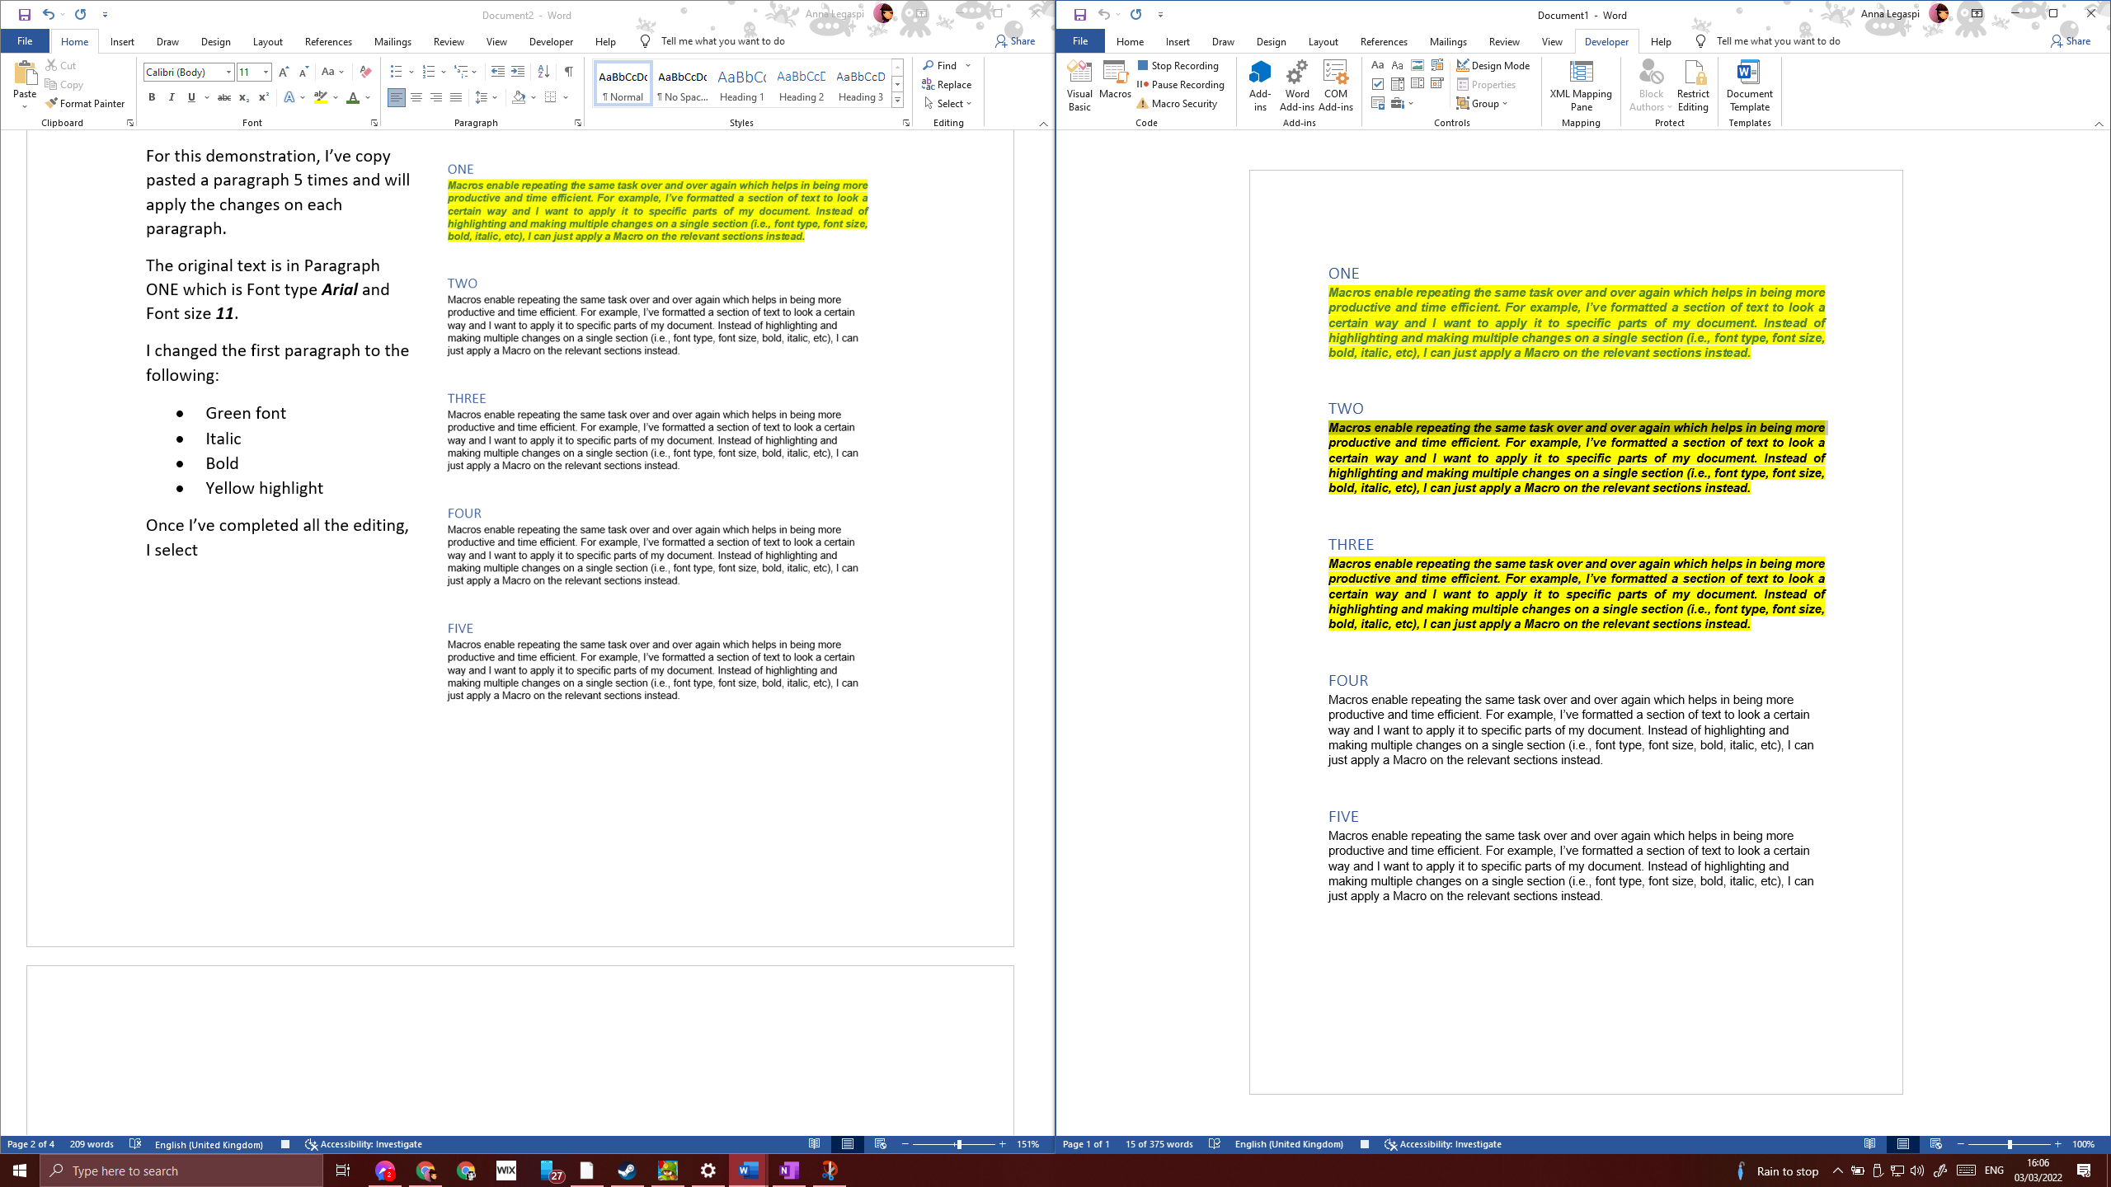



Following this, I highlight Paragraph two and press ***ALT+T***.

This copies the style I’ve applied on Paragraph ONE to paragraph TWO.

I highlight Paragaph THREE and press ***ALT+T.***

This copies the same style to Paragraph THREE.

I can do this repeatedly to any text I highlight.

